Research Log

Learner Name |  |  |  | Learner number
Centre Name |  |  |  | Centre Number
Supervisor
Proposed project title
This form should be used to record the process of your project and be submitted as evidence with the final piece of work.
You may want to discuss:
- what you have done (eg, from one week to the next)
- if you are working in a group, what discussions you have had
- any changes that you have or will need to make to your plans
- what resources you have found or hope to find
- what problems you are encountering and how you are solving them
- what you are going to do next

Date | Comments
2022.2.10 | Today I got an overview of the EPQ project, including its aim. Significance, process, timeline, requirements, etc. I also reviewed some details I should keep in mind of when choosing a topic and carrying it out, such as the SMART principle. It tells me that when choosing a topic and working on it, it should be specific, measurable, attainable, relevant and time-bounded. After reading several topics and articles related to the field I’m interested in, several thoughts of what I should research came to me, including investigating the fragmentation and breaking of brittle rods such as chalk. After digging deep into this idea, I found that the fracture process is very interesting and it seems that no one had done it before. Another idea is to investigate the physics interpretation of timbre and sound. The sounds we hear today may actually be formed by the synthesis of different sine waves, maybe altering the component waves may give us different sounds.
2022.2.11 | Today, I learned to the websites and apps to search for and download articles related to my topic. The websites that I got to know from includes: CNKI.net, Baidu Scholar, National Library of China in China, and Google Scholar, sci-hub, semantic scholar, z-library, etc.. These websites are settled by universities or national institutes and they have collected over millions of academic scientific articles. I’ve read many academical materials about the physics process of fragmentation. I revised my mind map and got a brief overview of the background, the significance and the objectives of my project. I also made a draft of my experiment that I’m about to conduct.
2022.2.12 | Today I made an overall schedule of my EPQ project. A detailed plan was made with a GANTT diagram to let me get an overview and plan my whole EPQ project. I read an article named Controlling fracture cascades through twisting and quenching written by Basile Audoly and Sebastien Neukirch, to notice that Sebastien Neukirch is the author who wrote Fragmentation of rods by cascading cracks: why spaghetti do not break in half and won the 2006 Ig Nobel prize. Although the article is not very relevant to my project, I learned some formulae about material science and some interesting properties of rods.
2022.2.13 | Today I learned the basic knowledge of how to write an appropriate abstract, introduction, literature review, discussion and conclusion and began to write a first draft of my introduction. At first, I am afraid that I will have few references related to my subject, but as I consulted the websites, I found out that there are already plenty of research done on the fracture of rods, from chimneys to broomsticks.
2022.2.14 | Today I learned the points I need to know when writing an academic project. I should use less subjective sentences and use more objective sentences. It occurred to me that the title of my project was not very accurate and after looking up many professional essays and articles, I decided to change my project name into Cascading Fragmentation of Cylindrical Brittle Rods when Hitting Hard Surfaces: Why Chalk do not Break in Half. I realised that I should not only study on chalk but also focus on other materials and get a general solution. I also get start writing my PPT for the proposal.
2022.2.16 | Today I went to search for the information needed for this topic. I downloaded a lot of articles, but found that many of them were irrelevant to my field of research. Then, I began to search in a more precise way and read the abstract of each article to determine whether it is useful to my research I also found that my topic of research is related to a newly-founded subject in science: Fracture Mechanics. However, this subject is pretty advanced and uses a lot of prepositive knowledge from physics and materials mechanics. I plan to learn some of the knowledge needed in physics, materials science and fracture mechanics for the project.
2022.2.17 | Today when I was doing my PPT I think that there are still some flaws in my project. I should use the analyses and theories that I get in the project to solve some specific problems in real life. Maybe I can later invent a kind of chalk or chalk holder that can prevent the cascading fragmentation or use this in medical science. I am still considering on this point.
2022.2.19 | I had my first online meeting with my tutor, Mr. Wan. He is a professional in fracture mechanics, which is very related to my subject. At first, he mentioned the title of my project and gave me an advice to fully understand the academic meaning of each word in the subject. Later, we discussed the outlined of my essay, including how and what I should write in the literature review. Afterwards, we discussed the details of my experiment. My tutor gave me some really helpful suggestions. He suggests that I can use a microscope to examine the fracture of the rods and I can use different kinds of chalk and compare the fracture. He also recommended some useful software and reference books I should read, which gave me a lot of help. He also told me that it would already be great enough to use the experiment results to solve and explain a phenomenon, and a practical use of the explanations is not very necessary.
2022.2.21 | Today I will be starting an outline of my essay. I have set a goal to complete the literature review part of my essay before 3.20. As I still need to learn a lot of knowledge about physics, materials science and fracture mechanics, this will be a huge challenge for me. From now on, my initial planning and confirmation has almost finished. I had my topic and I know the way to research, at least the direction of research. Even though I have a lot of pressure I still believe I will have a good result in my EPQ project.
2022.2.28 | I found that there is still a lot of knowledge about materials science that I needed to learn. My tutor gave me an advice to read some books and listen to open course wares on the internet. This is definitely a timely advice. I listened to an open courseware by TsingHua university on bilibili.com to study some basics of materials science. Here is a picture of it.  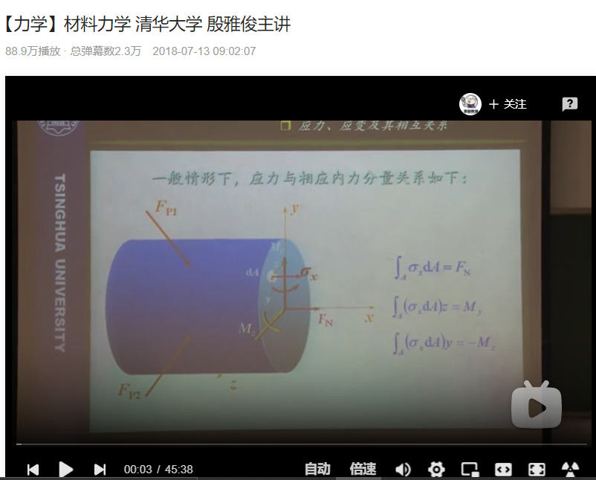  It is hard to catch up with the original speed of the course because it uses a lot of knowledge of calculus that I am not very skilled in. I plan to review these calculus skills by reading the calculus book from Cambridge University and by reviewing the A-level books.  In addition, I also read a book called Fracture Mechanics: Fundamentals and Applications, which was recommended by my tutor. After it, I got a brief idea of the reasons and causes of the fracture of materials. Here is the picture of the cover front of the book:  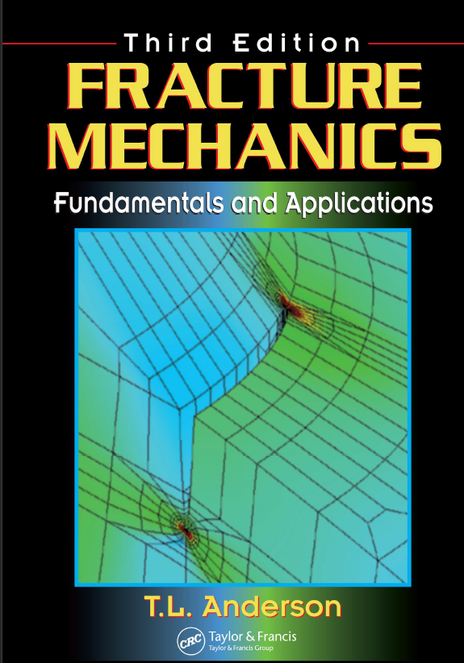
2022.3.3 | After several days of studying the knowledge of physics, materials science and fracture mechanics, I obtained some basic knowledge of the fracture process. For different kinds of materials, the fracture condition and its cause and characterization will be different. There are two kinds of materials, brittle and ductile. Material failures are often caused by stresses. Based on the stress-strain graphs, brittle materials have no clear yield point and will break when receives relatively little energy. Ductile materials will yield under stress and receive a relatively large amount of energy. I think that chalk is a kind of ductile material. In order to prove my guess, I have ordered three types of chalk online, and in the future, I will read articles about the mechanical properties of chalk. I chose the chalk rods based on its price and description in order to have different toughness.
2022.3.10 | The chalk that I ordered hasn’t arrived, but I conquered some difficulties while searching for the mechanical properties of chalk. When I search for “chalk” on google scholar or on other scholarly websites, nearly all of them are talking about a mineral, but not blackboard chalk. I am very confused about the relationship between “mineral chalk” and “blackboard chalk”. There are a lot of articles and research on mineral chalk, but very few are directed to blackboard chalk. Even if these two are the same, I didn’t find any results stating the mechanical properties of chalk, which is very confusing.
2022.3.12 | Today I found that I have always been making a mistake by only consulting articles that are published after the year 2015. This is because the default configurations of google scholar only show the results after 2015 and for semantic scholar it only shows results that are published after 2018. After turning off this searching filter, many more results are shown, including the research papers that covered the mechanical properties of chalk. By looking over these papers, I get to know that mineral chalk is a brittle material and often undergoes fracture under shear stress or tensile stress. However, chalk differs slightly from place to place and there is still some physics and materials science knowledge that I need to learn.  It turns out that the book Fracture Mechanics was a bit too hard for me and I do not have to dig so deep and use a lot of advanced knowledge in the book to finish the project. So, I only read the basic parts of it. Also, in the past few days I have been watching open course wares from Fudan University And MIT. Here are some pictures of the open courseware that I listened.  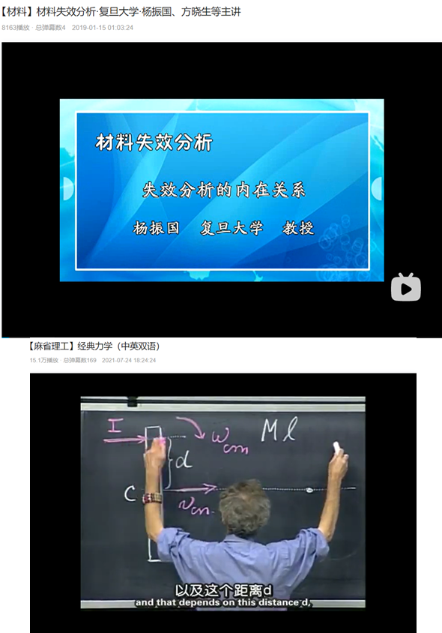
2022.3.14 | The good part is that two of the three types of chalk that I ordered finally arrived. I immediately started dropping them as I know practice is the test of truth. I found that chalk begins to break even at a height of only 20cm, which is a much lower height than I’ve expected. An interesting phenomenon is that different types of chalk will behave differently. The one that is more expensive tend to fracture into less pieces. This phenomenon that I discovered by accident gave me an inspiration and directed me to notice that not only drop height but also the type of material will influence the fracture progress. I found that chalk breaks instantly without any necking, which proves my hypothesis that this is a kind of brittle material. In addition, I tried to film the process, but I found that normal cameras cannot catch the fracture process. Then, I switched to a slow-motion camera, but found that slow-motion videos need a huge illumination for the videos to be clear, or else it will be pitch dark. The only video that I got which wasn’t dark didn’t have the proper camera focus! This upsets me a bit, but I believe that I will find a way to tackle these problems.
2022.3.16 | Today I read a very important article talking about the manufacturing process of chalk, called Design and Fabrication of Automatic Dustless Chalk Making Machine. I found that chalk rods used in teaching today can be classified into two major categories: normal chalk and dustless chalk. More than 90% of the types of normal chalk is made of calcium sulfate (CaSO4), which is derived from gypsum (CaSO4-2H2O), an evaporite mineral formed by the deposition of ocean brine. Normal chalk also contains small amounts kaolin clay, Oleic acid, and Sodium hydroxide. Chalk and dehydrated gypsum thus have similar origins and properties. Pastels also contain clays and oils for binding, and strong pigments. This mixture produces sticks that write smoothly without smearing and draw better on paper than on chalkboards. As calcium sulfate (gypsum) based normal chalks are widely used for teaching, More and more schools began to adopt a new kind of dustless chalk. In contrast, dustless chalks are manufactured, using a high-pressure extrusion process with polymeric binders, in developed countries like the USA, UK, EU countries, and Korea (Nasir, 2002). The main raw materials for dustless chalk are a mixture of calcium carbonate and calcium sulfate (gypsum) with the addition of polymeric binder so that they can adhere more closely to do the deed of dust-free, e.g., PVA, PVP, starch, etc.
2022.3.18 | Although the sudden outburst of the pandemic messed up with my plan a bit, but in the past few days, I read several important and useful articles and have some good progresses.  An interesting event that I experienced is that no sooner have I finished reading this article than the dustless chalk arrives! I tried to break it, and the mechanical properties are consistent with the article I read.  In addition, I listened to an open courseware of Fudan University talking about the failure analysis of materials. It appeared to me that the fracture of materials can be very complex and varied, which causes me to worry about the difficulties that I might conquer in this program.
2022.3.20 | I had a conversation using messages with my tutor on, which was definitely inspiring. I understood the complexity of fracture mechanics but based on the research that I am doing now, nearly most of these difficulties can find points to breakthrough. He told me that factors that will cause a material to fail or fracture will be varied due to different kind of stresses. He told me that the cause of these stress can be analysed by observing the fracture surface of the material, and the forces that will cause the material to fracture. It seems that I have to read articles and watch course wares again! So I changed my plan to finish my literature review to 3.25 for me to read articles
2022.3.23 | I have finished my literature review, which was three days after my initial plan. In process of literature review, I gradually noticed the limitations of my knowledge and the complexity as well as the fasciation of this article. The fracture of materials requires knowledge about physics, material science and fracture mechanics. The process of reading articles, textbooks, watching open course wares is a difficult and challenging process. In order to understand the articles, I need to master the knowledge of calculus and basic physics. Sometimes I have to spend hours trying to understand one point made by the author in textbooks or articles, but only to find that this point is relatively irrelevant to my literature review and is nearly useless to this research. At first, I conquered a lot of articles which I spent a huge amount of time trying to understand but to find that it is irrelevant to my research. As I read more and consulted more, I began to search for and read articles more efficiently. This skill will definitely be useful in my future studies.
2022.3.30 | In the last week I have been preparing for the PhysicsBowl contest, so the proceeding of my project had been ceased. Then I thought about some details of my experiment in these days after exam revision. In order to investigate the fracture process, I will have to use a slow-motion camera to film it. However, lighting and focus will remain a huge difficulty. For the illumination part, I plan to purchase some flashlights to illuminate the whole setup and environment of the experiment. For the focus problem, I plan to use three cameras at different angles to film the process.
2022.4.3 | Today I recorded the basic parameters of three types of chalk, as follows.  Table 1: The parameters of three types of chalk  Type Original Length/mm Radius/cm Shape Composition  Chalk A 80±1 10±0.5 cylindrical Hardened chalk  Chalk B 81±1.5 9.5±1 cylindrical gypsum  Chalk C 72±2 Larger end: 10±1 Smaller end:8±1 hexagonal prism gypsum  It actually took me quite a while to record these data, but I believe that this will be useful for further studies. I also did some trials on the experiment since the flashlights have arrived. The illumination problem was successfully solved, as I used three flashlights to film the whole process. However, another problem occurred. Since the background—the wall is white, the fracture process cannot be clearly recorded. I plan to use some black tablets in the background to fix this problem. The design of the experiment is another problem. There are a lot of variables to consider and a lot of quantities. I plan to investigate on the effect of material on chalk on fracture and the effect of drop height on chalk fracture. One way of investigating the effect of material on fracture is to drop different kinds of chalk at the same height and compare the number of pieces after fracture. The day after tomorrow I will be having a class with my class tutor I am very looking forward towards it because I have already completed a draft of my methodology.
2022.4.6 | Today I was preparing the setup of the experiment. To keep the integrity of the experiment, I acquired some camera parameters of the three cameras that I will use and also the parameters of my microscope. The results are as follows:  Name and model Quad Video Framerate Size  Camera A: Xiaomi 10 main 1080P 120FPS 16:09  Camera B: Mate40 main 4K 7680FPS 16:09  Camera C: Ipad pro main 1080P HD 340FPS 4:0 3  Model Ocular lens Magnification lens Objective lens Work area  Ruihoge XSP-02-640 16× or 25× 2× 10×, 40×, 125× 120×110mm  In order to control the height, I drew lines on the wall to ensure that the drop height is accurate. Also, I found two black tablets that is perfect to provide a background for the test environment. It appears to me that I haven’t thought a proper way to measure the ground angle. I also started to do the experiments of the effect of material on fracture, but I found that the experiment seems to have a great overlap on the experiment that I am about to do on the effect of drop height on fracture.
2022.4.8 | Today I was preparing the setup of the experiment. In order to control the height, I drew lines on the wall to ensure that the drop height is accurate. Also, I found two black tablets that is perfect to provide a background for the test environment. It appears to me that I haven’t thought a proper way to measure the ground angle. I also started to do the experiments of the effect of material on fracture, but I found that the experiment seems to have a great overlap on the experiment that I am about to do on the effect of drop height on fracture. A lot of previous trials have been done and I have to adjust the positions of the cameras, flashlights, background and other equipment. This will be a very huge amount of measures and recordings that I have to do, because I plan to record the length of fracture for every drop. The setup can be seen in the following picture:  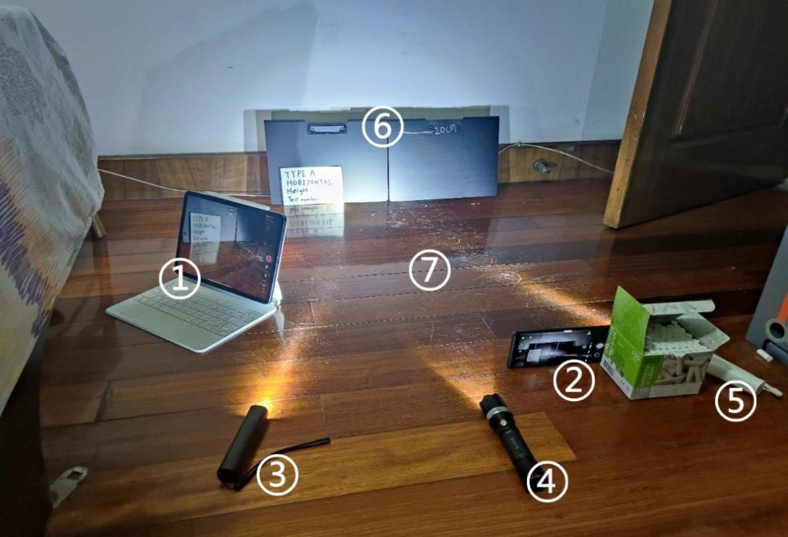  Chalk are dropped onto ground at area ⑦ with axis parallel to ⑥. ⑥ are two black tablets that provide a background for the filming. The fracture process is recorded by camera ① and ② at two separate angles ( ① is camera C and ② is camera B): camera ② will be filming against the major axis of the chalk while camera ① is filmed at an angle of 45° against chalk’s major axis. ③④⑤ are flashlights places on the ground at three different angles that provide a strong and stable light source for the recording to be clear and full.
2022.4.10 | In the last two days I have been refining the hypothesis for my experiment. My tutor gave me some suggestions about my methodology, and after reading several literatures, I noticed that I will have to write it using a more academic way, and the first and second experiment have a great amount of overlap, so I have to redesign it. It seems that the experiments that I did before have to be abandoned.
2022,4.12 | I have finished designing a newly refined version of my experiment methodology. In this experiment, I plan to investigate on the effect of drop angle and drop height on chalk fracture. The effect of material on chalk fracture can be investigated by determining the lowest height for horizontal chalk to break when dropped onto horizontal ground. Through this experiment, we can acquire the impact toughness of different kinds of chalk. The second experiment that I will make is to investigate the effect of drop height on chalk fracture. Therefore, chalk is dropped at 7 equidistant heights ranging from 20 cm to 80 cm. I will record the fracture length and fracture pieces of each drop and compared. I think the advantage for this experiment that by dropping three types of chalk, the effect of the material on drop can also be shown in this experiment, in order to prove the results of the previous experiment.
2022.4.14 | Today I conducted the experiment on the effect of drop height on fracture and recorded the results. At first it appeared to me that it would be quick, because I thought that the experiment was no more than just dropping chalk rods. However, It took me over 4 hours to complete this experiment, because I had to drop the chalk over 150 times and for every drop, I have to collect the broken pieces of chalk and record their fracture length. By recording the fracture length, I found that when chalk rods are fractured into two pieces they usually roughly break in half, which is a very interesting phenomenon to note. However, when chalk rods break into three pieces, they do not have roughly equal lengths. In most cases, there would be one big piece that has the length of about half of the rod and the other two pieces about one-fourth.  The most annoying and time-consuming part is to record the ground angle, as I had to look over the slow-motion videos one by one. I haven’t completed the recording, and I will continue to do it tomorrow. Here is a picture of some of the videos that I recorded.  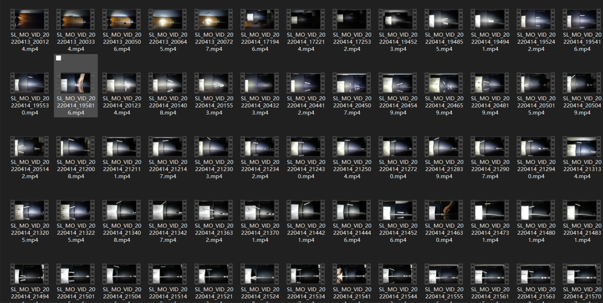
2022.4.15 | Today I had the results of the experiment that I did yesterday AND converted them to an excel file. It was not an easy process, as I have recorded over one hundred sets of data. By comparing the fracture condition at the same height for each type of chalk. Then, in order to prove my hypothesis on the effect of drop height on fracture, I did a linear regression on the effect of drop height and the number of pieces of drop. Initially, my plan was to use python to draw a regression but it turned out that I was rusty on python and couldn’t get the codes to work properly. Then, I learned how to use excel to make linear regressions. The results turned out that the number of pieces is not strongly correlated with the height of drop, which confuses me a lot. After reviewing almost all of the videos, I found that the angle of the axis between horizontal ground when touching the floor will differ and might have a large influence. The results of the experiment are as follows:  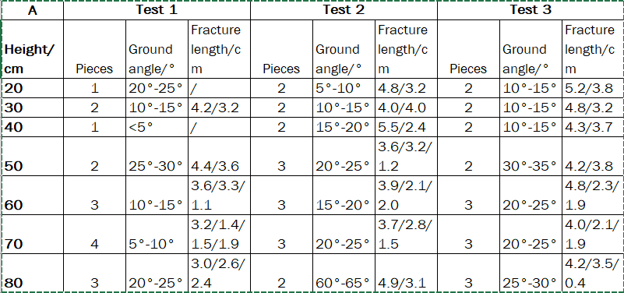  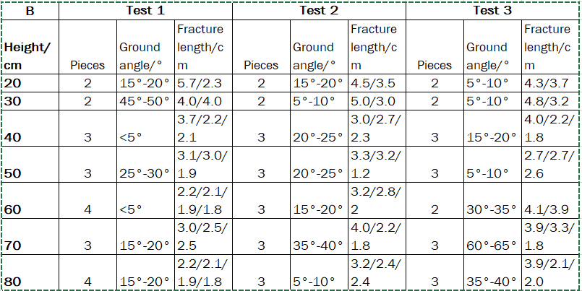  Tonight, I had a course with my tutor. He gave me a lot of vital advice. First, I should define the quantities in my experiment, such as drop height, drop angle and ground angle. Second, I should observe the fracture pieces and perhaps the powder of chalk to get more information about the materials. Third, in order to control variables, I only need to use one, at most two, sets of data in the discussion part of the effect of drop height on fracture. Finally, in order to control variables, I should use one type of chalk to drop at a certain height and discuss the ground angles. I came up with an idea to drop the chalk at different ground angles in order to have a wider range of ground angles.
2022.4.17 | In the last few days I did quite a lot of things. First I observed the fracture surfaces of three types of chalk and the powder of three types of chalk, As the following pictures show.  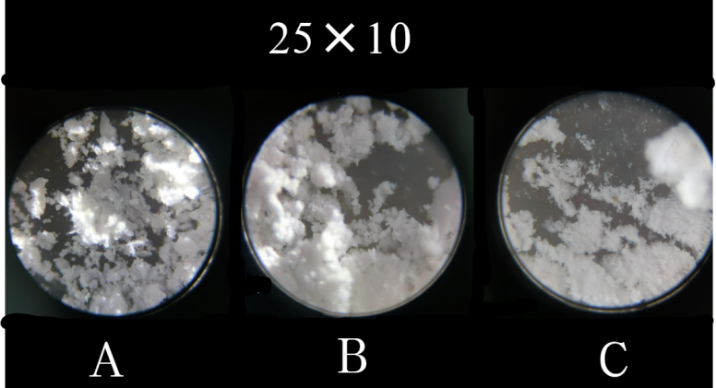  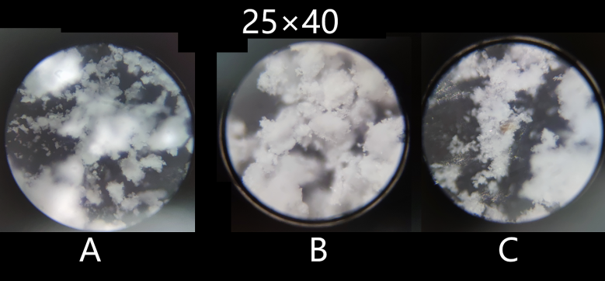  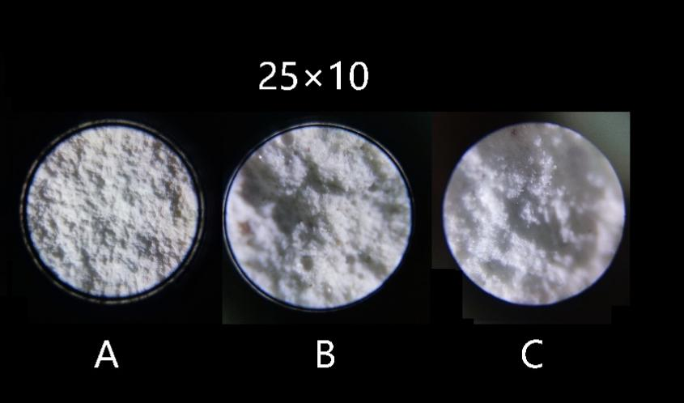  The pictures are fascinating and it was such a pleasure to observe them. I couldn’t imagine that microscopically the components are so beautiful.  I also finished writing the discussion part of the effect of drop angle on height. In addition, today I conducted the experiment of ground angle on fracture. I am still processing the data and will finish them tomorrow.
2022.4.20 | I have finished my recording of the data recorded from the experiment. The data collected are as follows: 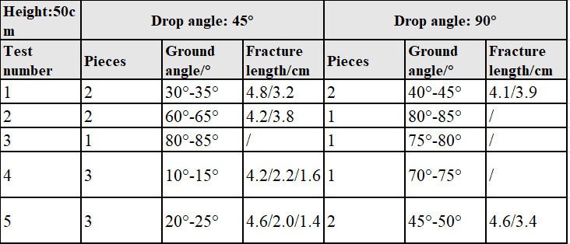  The results show that there are no obvious relationships between drop angle and ground angle, especially at a high drop height. This is due to the falling procedure is not idealistic and will be influenced by many factors such as air resistance. The result also shows that the relationships between fracture and drop angle are small, thus it is more reasonable to study the relationship between fracture and ground angle. The data is analysed through correlation and the results are as follows:  Today I also had a lecture with my tutor. In the lecture, I gave some of my assumptions of the interpretation of the fracture process. He gave me an advice to determine the cause of fracture by the knowledge that I learned before, especially by the fracture morphology of the materials and by looking over the videos that I recorded.
2022.4.22 | Today I followed my tutor’s advice and observed the fracture surfaces, which definitely gave me vital information. By watching the slow-motion replays and observing fracture surfaces, it is found that the fracture process and fracture surface for different ground angles are significantly different. For small drop angles, typical fracture characterizations of chalk are as follows:  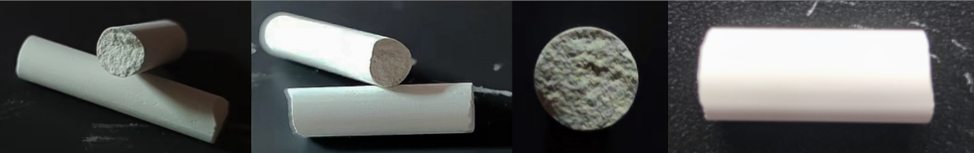  The fracture surface is approximately perpendicular to the major axis of chalk. This implies that the fracture of chalk is most likely to be caused by a tensile bending stress. Insignificant facets are observed and the size of the facet will tend to increase as the drop angle increases. This implies that a shear stress might also contribute to the fracture process, and the effect of shear stress will increase as the drop angle increases.  For large drop angles, typical fracture characterizations of chalk are as follows:  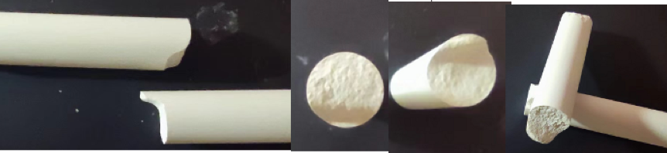  The fracture surface is uneven with a large facet on the side. This implies that for a large drop angle, the fracture is most likely to be caused by a shear stress.
2022.4.24 | In the past two days, I have finished my discussion part. I had to adjust my timescales since I spent a very long time in my experiment. I was working day and night in the past few days in order to finish my discussion part online. Looking back, I believe that I could manage my time in a more efficient way, but I am also proud of what I had done and accomplished in the last few days. I still remember that I spent hours just to make several graphical interpretations of the forces, stresses and motions that a chalk rod would undergo when touching the ground. Here are some of them:  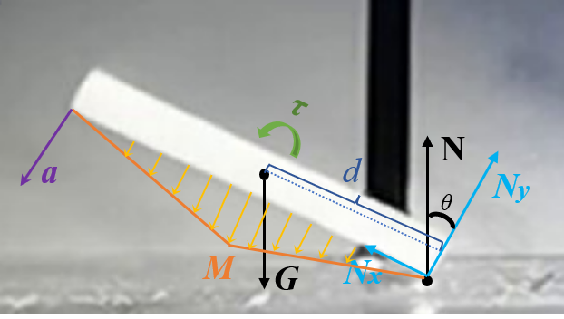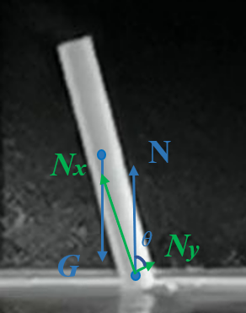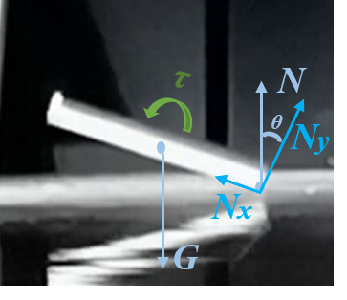  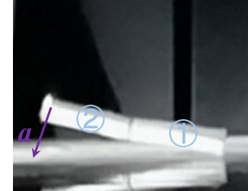  Today I also started to prepare my PPT for the final presentation. One problem is that I found the experiments I did was too rich in content and I found it hard to put them under 20 minutes and in a logical manner. I am thinking just to briefly introduce the background and objectives part and the literature review part. Some of my friends say that they will be having a part describing the thesis of their paper, but I don’t think that I have enough time for an individual part to introduce. An outline and frame of my PPT had been set up, including, Background and objectives, literature review, experiments, results and discussion, conclusion and evaluation. I am still wondering what should I emphasize in each part.  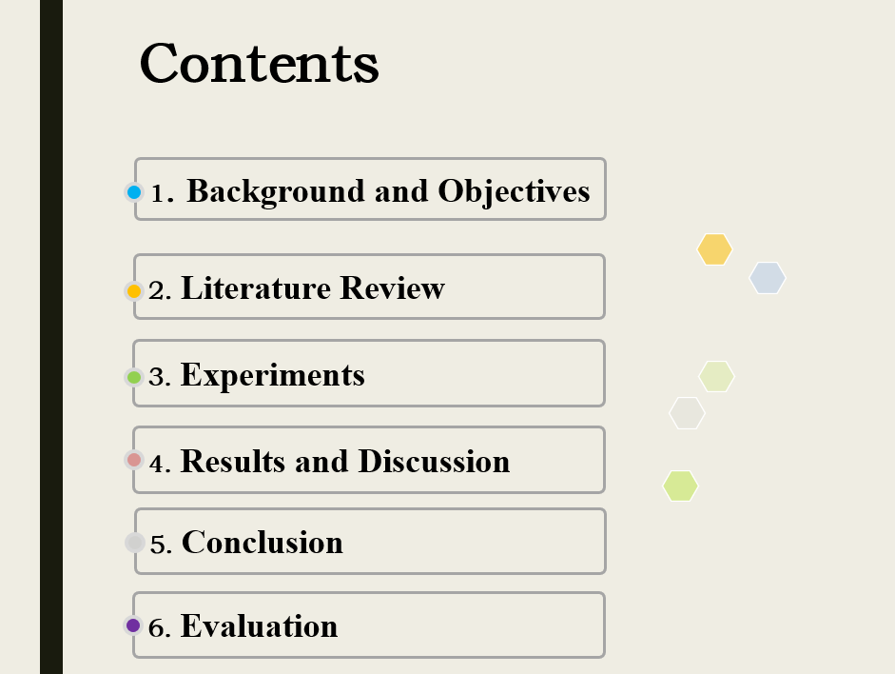  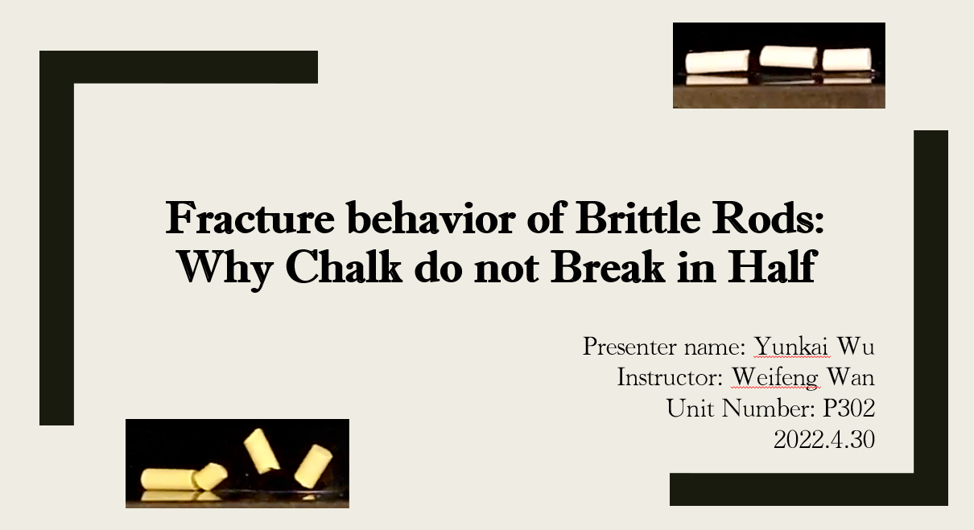
2022.4.27 | I have finished my PPT and am preparing for my presentation. This might be my last log. Reviewing the whole project, I have learned knowledge about physics, materials science and fracture mechanics; I have successfully designed and conducted an experiment with the help of my tutor, Mr. Wan; I have analysed the data obtained from the experiment using various methods; I have improved my time management skills, and I will keep on practising the presentation to improve my presentation skills.  I would like to thank my tutor, Mr. Wan, as he helped me to overcome difficulties and guided me in the right direction as well as enabled me to think and discover by myself. I am also grateful for the help and support from other teachers and my parents.

